MCQ (20 questions total) – Only ones I remember (Answer at the last page)

1. ‘comprehension’ – which ones can be subsequences
2. ‘pre’
3. ‘chin’
4. ‘oio’
5. only i
6. only ii
7. only iii
8. i and ii but not iii
9. ii and iii but not ii
10. i and iii but not ii
11. i, ii, and iii
12. a = 5

b = a % 3

a = a ** 2

print(a, ‘and’, b)

1. 5 and 2
2. 5 and 3
3. 25 and 5
4. 25 and 2
5. 25 and 3
6. Which one is not True?
7. A subclass does not need a constructor
8. Subclasses can override the methods of the superclass
9. Subclasses cannot get access to the method of the superclass if it overrides it
10. If a subclass inherits a class, that class is known as its superclass
11. (Forgot)

foo(a,b):

a = b * 2

b = a – 1

return b

a = 2

b = 3

b = foo(a,b)

a = foo(b,a)

foo(b,b)

print(a,b)

What is the output?

1. 2 3
2. 2 5
3. 3 3
4. 3 5
5. 9 10
6. 3 10
7. mystery(a,b):

if b > a:

return b

else:

rest = a + mystery(a//2, b + 1)

mystery(8,1) returns what?

1. 8
2. 11
3. 12
4. 15
5. 19

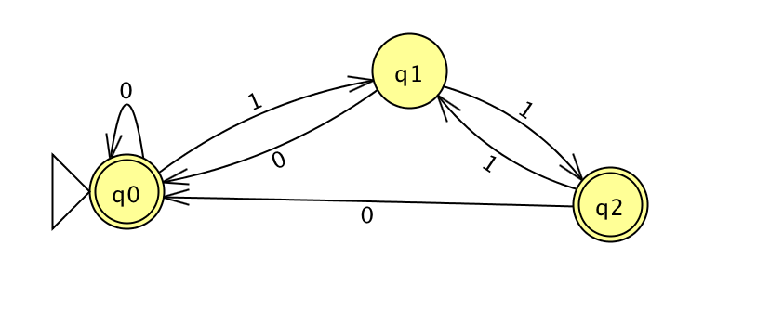

Accepts Which ones?

1. Strings ending with ‘111’
2. Strings ending with ‘0’
3. Strings that have even number of ‘1’
4. Only i
5. Only ii
6. Only iii
7. I and ii but not iii
8. I and iii but not ii
9. ii and iii but not i
10. i, ii, and iii

00 read r1

01 add r3 r1 r1

02 call r14 05

03 write r3

04 halt

05 copy r5 r3

06 jeqz r5 10

07 addn r5 -1

08 add r3 r3 r5

09 jumpn 06

10 jumpr r14

What is the answer when the input is 3?

1. 3
2. 5
3. 7
4. 9
5. 12
6. 21
7. None of the above
8. If it takes 2 seconds to sort 100,000 items and takes 8 seconds to sort 200,000 items, what is the search?
9. Binary search
10. Quicksort
11. Selection Sort
12. Log n
13. None of the above
14. How do you get access of the number of columns in a 2D list that has at least one column called grid?
15. len(grid)
16. len(grid[0])
17. grid[0]
18. grid(len)
19. None of the above
20. Suppose there is a class called Tea that has variables

amount: The amount of tea in integer

store: The place it is stored in string

weight- unit: the unit of measurement in string

What is the appropriate code that allows the user to print the information?

ex) tea_one = Tea(2.5, ‘cup’, ‘gram’)

print(tea_one) prints ------ 2.5 cup gram

1. def str(self):

return self._______ (forgot)

1. def str(self):

return self._______ (forgot)

1. def __repr__(self):

return print(self.amount, self.store, self.weight)

1. def __repr__(self, amount, store, weight):

return str(self.amount) + self.store + self.weight

1. def __repr__(self):

return str(self.amount) + self.store + self.weight

1. More than one of the above
2. X = [101,103,105,108,109,111]

Which one of the below stores [105,109]

* 1. X[2:3] + X[4:5]
  2. X[2] + X[4]
  3. X[2::2]

1. Only a
2. Only b
3. Only c
4. a and b but not c
5. a and c but not b
6. b and c but not a
7. a, b, and c
8. a = [1,2,3,4,5,6]

b = a[:]

c = b

c[3] = a[2]

a[2] = b[3]

b[3] = c[3]

print(a[2], b[3])

What is printed?

1. 3 3
2. 2 3
3. 2 2
4. 4 4
5. 4 3
6. None of the above
7. x = 30

y = 20

if x> 20 or y < 15:

print(‘fit’)

if x > 30:

print(‘fad’)

print(‘fid’)

elif x < 15 or y > 15:

print(‘fax’)

elif x > 30 or y > 30:

print(‘fla’)

if x > 4:

print(‘fed’)

What is the value printed? (forgot the choices)

1. [x -1 for x in range(2,7) if x %2 ==1]

What is printed for the list comprehension above?

1. 3 5
2. 2 4 6
3. 2 4
4. 3 5 7
5. None of the above
6. Which one the below is not True?
7. The value of local variable can be accessed in global scope
8. The value of global variable can be accessed in a function
9. Functions can have more than one return statement
10. Function automatically ends after a return statement
11. (Forgot)
12. What is the value of x?

dict = {2:4, 5: 7, 4: 5}

x = 3

for key in dict:

if key % 2 == 0:

x += key

print(x)

1. 5
2. 7
3. 9
4. 11
5. 13
6. None of the above
7. What is the truth table for the picture below?

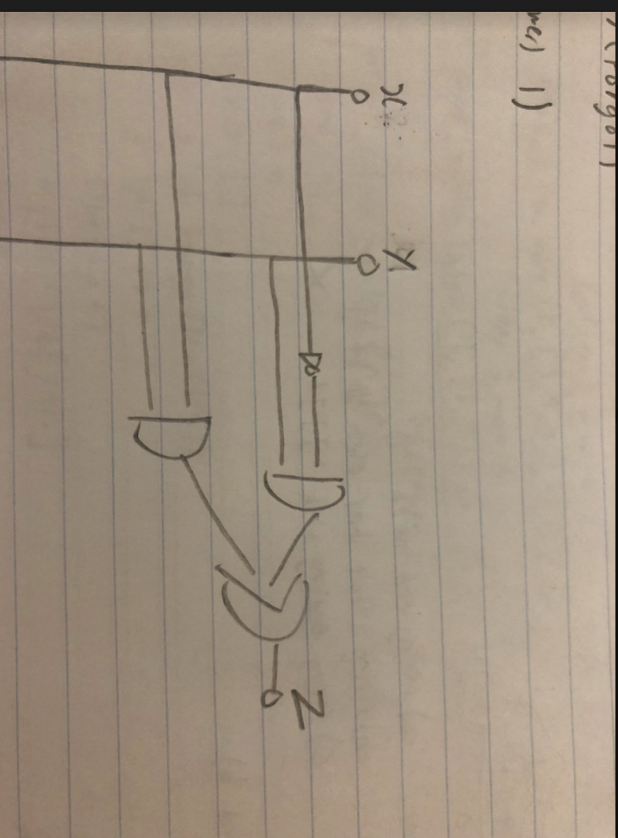

1. x y z b. x y z c. x y z d. x y z

0 0 0 0 0 0 0 0 1 0 0 1

0 1 0 0 1 1 0 1 1 0 1 0

1 0 1 1 0 0 1 0 0 1 0 1

1 1 1 1 1 1 1 1 0 1 1 0

1. mystery(a, i):

j = 1

for x in range(len(a)):

a[x] += j

j += 1

return a[i]

a = [1,2,3,4,5]

print(mystery(a,1), a[1])

What is printed?

1. 2 2
2. 2 3
3. 3 2
4. 3 3
5. 4 3
6. 3 4
7. 4 4
8. None of the above
9. def mystery(word,char):

x = 0

while len(word) != 0:

for I in range(len(word)):

if word[i] == char:

word = word[i+1:]

x += i

break

return x

What is the value returned for mystery(‘iterate’,’e’)?

1. 2
2. 3
3. 5
4. 6
5. 8

Answer:

1. a) only i
2. d) 25 and 2
3. c) Subclasses cannot get access to the method of the superclass if it overrides it
4. d) 3 5
5. d) 15
6. f) ii and iii but not i
7. f) 21
8. e) None of the above
9. b) len(grid[0])
10. e)
11. e) a and c but not b
12. a) 3 3
13. fit

fid

fed

1. c) 2 4
2. a) The value of local variable can be accessed in global scope
3. c) 9
4. a)
5. g) 4 4
6. c) 5